Unit 11 | Sensing the Environment
Topic: What are the factors affecting reaction time?
Name: _____________________
Class: __________________( )
Date: ________________________

The time that a person grasps a falling ruler is a measure of his reaction time.
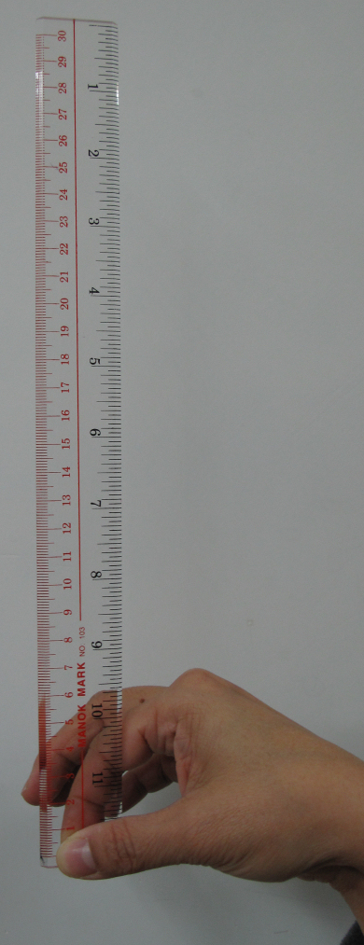 |  | 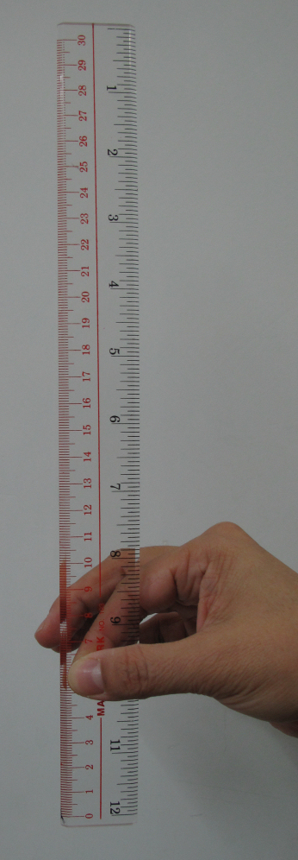
Hold one end of a ruler vertically. | Release the ruler so that it falls vertically and then try to grasp it again. | Grasp the ruler. Determine the time to grasp the ruler, i.e. the reaction time, from the distance it falls.

1. The reaction time is affected by different factors. List out some factors that possibly affect reaction time:
Whether a cue is given (With countdown vs. Without countdown)
The catcher’s degree of concentration (Blindfolded vs. Not blindfolded)
Trained vs. Not trained

2. For some of the factors listed above, design an appropriate setup / describe procedures to measure the reaction time and a suitable table to record the data.
Factor 1:
With Countdown:
The dropper counts down ‘3, ‘2’, ‘1’, ‘0’ and then releases the ruler
Without Countdown:
The dropper says ‘release’ and releases the ruler immediately

Factor 2:
Blindfolded
The catcher puts on a blindfold or closes his eyes

Factor 3:
Trained
The catcher makes several informal trials before the experiment is carried out

3. Suggest a precaution that the dropper (the student who holds and releases the ruler) should take to make the results accurate.
The ruler should be held vertically and then releases to fall vertically.

Results
Refer to the graph in the Appendix to convert the distance of the ruler fallen to time.
Factor 1:
 | Trial 1 | Trial 2 | Trial 3 | Trial 4 | Trial 5 | Average

Factor 2:
 | Trial 1 | Trial 2 | Trial 3 | Trial 4 | Trial 5 | Average

Factor 3:
 | Trial 1 | Trial 2 | Trial 3 | Trial 4 | Trial 5 | Average

4. Why do we need to repeat several trials and take the average value of the reaction time?
To reduce and average out errors.

5. What is the best reaction time (i.e. the shortest reaction time) ?

6. Look at the pattern of the readings recorded. What conclusion(s) can be drawn?
Reaction time can be improved when a cue is given (e.g. with countdown)
Reaction time can be improved when a catcher concentrates (e.g. blindfolded)
Reaction time can be improved when a catcher is trained.

7. Besides the factors that you have investigated that might affect reaction time, suggest some other factors that affect reaction time.
Age
Gender

8. Present your findings and conclusions in the most suitable way.
Appendix
Conversion graph of distance the ruler fell and the reaction time

